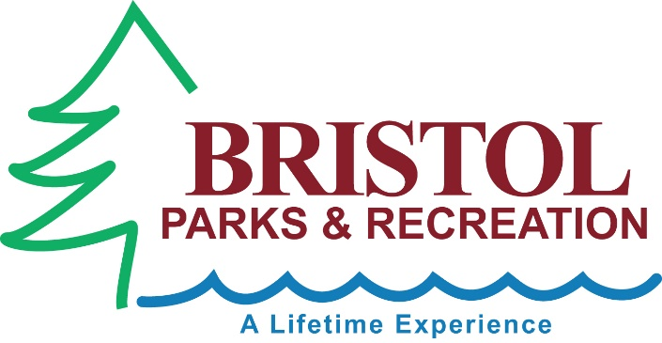
B.A.R.K PARK at Rockwell Park, Bristol, CT 06010
Located in picturesque Rockwell Park, the B.A.R.K Park Off-Leash Dog Park features two separate areas for large and small canines. Pups who are 18 inches or shorter at the shoulder are recommended to stick to the small dog side, while everyone else goes to the big dog side. BARK Park sits on a wooded hillside, giving four-legged visitors a steep incline to run up and down, plus several trees keeping most of the area shaded and cool even on hot days. There is no water available on-site, though, so please remember to bring your own regardless of weather.
You and your dog are welcome to explore the rest of Rockwell Park, but your dog must remain leashed once they are outside the dog park. The Park is open from sunrise to set.
Directions: Take Route 6 to Route 69, take a left on Route 69 (West St). Go to Route 72 (Park Street) take a right, bear right and stay on Park Street Pass main entrance to Rockwell Park, pass DiGiovanni's Auto Shop and entrance will be on the right (no sign but visible park entrance). Go in a short way and parking lot is on left.

B.A.R.K PARK OFF-LEASH DOG AREA RULES
BASICS:
- Hours: Sunrise to Sunset daily
- The off-leash area is for dogs, their handlers and those accompanying them. No other use is allowed.
DOGS MUST:
- Be legally Licensed and vaccinated, and shall wear visible god tags as proof. Dogs should also wear an owner identification tag at all times.
- Be on leash when entering and exiting the off-leash area. Keep the gates closed at all times except when walking through the transition (double-gated) areas.
- Be under the control of their owner/handler and in view of their owner/handler at all times.
- Enter into the appropriate fenced yard area according to their shoulder height:
Large/Medium dogs= Over 18inches, Small dogs=18 inches or under
- Be removed from the off-leash dog area at the first sign of aggression.
OWNERS/ HANDLERS MUST:
- Be 16 years of age or older.
- While inside the boundaries of the off-leash area, an adult must accompany and supervise minors under the age of sixteen (16). Children under the age of twelve (12) are not recommended.
- Have possession of each dog’s leash at all times.
- “Scoop the poop” and fill in any holes dug by the dog under their control.
- Take all personal property with them upon leaving in order to keep the park parasite and disease free.
PROHIBITED:
- Dogs under 4 months of age and female dogs in heat are prohibited.
- For the safety of your dog(s) and other park visitors, choke, prong (pinch) and spike collars are strictly prohibited. If you use these types of collars, remove them before entering the Dog Park.
- Food and drink in glass containers are prohibited; training treats are allowed.
- Smoking is prohibited inside the fenced in off-leash area. Please do not litter.
- Wheeled devices (ie. Skateboards, bicycles, wagons, rollerblades, strollers, etc.) are prohibited in the park, with the exception of wheelchairs.
Users of the park do so at their own risk, Neither the City of Bristol nor the Bristol Parks and Recreation Department shall be liable for any injury or damage caused by a dog in the off-leash area. Failure to abide by the park rules will result in loss of privileges or owner(s)/handler(s) may be ticketed.
EMERGENCY………………………………..911
BRISTOL ANIMAL CONTROL…………….860.584.3087
BRISTOL PARKS AND RECREATION……860.584.6160

