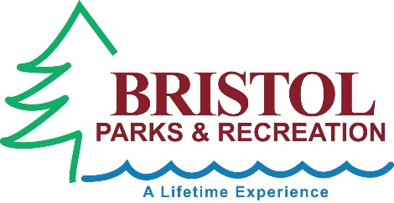

Recreation Internship
Job Description: The Recreation Intern performs a variety of duties assisting the Recreation Supervisor, Aquatics Supervisor, facilities Supervisor and the Superintendent of Parks and Recreation with daily operations of a busy, diverse and comprehensive summer Parks and Recreation Department.
General Duties:
- Assist with daily operations of the Summer FUN Camp, Little Explorers Camp and Teen Adventure Camp.
- Assist with preparing and leading summer staff orientation and aquatics staff in-services.
- Help plan and implement summer special events at the pool and parks.
- Assist in weekly Summer Concert Series – Tuesday evenings 6:45pm-8pm
- Assist with preparations for weekly seasonal payroll as needed.
- Work with MyRec software including registrations, reports, e-mail blasts, programming and other functions
- Assist in office coverage as needed. Answering phones, handling registrations, and assisting costumers.
- Will learn and be responsible for sending out press releases, surveys and program evaluations.
Qualifications:
- American Red Cross CPR/First Aid Certification (training provided)
- At least 18 years of age with a valid driver’s license and transportation.
- Preferred: Enrolled as an undergraduate or graduate in a Recreation & Leisure Program or Related Field.
Salary Range: Varies based on experience.
Hours: Varies but does include some weekend and evening hours (Averaging 25- 40 hours per week)

